## PROGRAM DEFINITION

|  |
| --- |
|  |
| * A program to print a report for a list of LOOs that need to be followed up on or have succeeded in becoming Letter of Consent (LOC) |

## RELATED TABLES

|  |  |
| --- | --- |
|  | **Access** |
| * PMT_AGREEMENT * PMM_TENANT * GSM_DEPARTMENT * PMM_SALESMAN * PMT_AGREEMENT_UNIT * GSM_TRANSACTION_CODE * GSM_PROPERTY_UNIT * PMT_AGREEMENT_DEPOSIT * GSM_PROPERTY_UNIT_TYPE * GSM_PROPERTY_UNIT_TYPE_CATEGORY * GSM_PROPERTY_UNIT_VIEW * PMM_PRICING * PMT_AGREEMENT_CHARGE * PMM_UNIT_CHARGES * GSM_TAX | * R * R * R * R * R * R * R * R * R * R * R * R * R * R * R |

## ROLES

|  |  |
| --- | --- |
|  | **Test** |
| * User that has access to program |  |

## INITIAL PROCESS

|  |  |
| --- | --- |
|  | **Test** |
| * Set **VAR_COMPANY_ID** = Login User’s Company ID * Set **VAR_USER_ID** = Login User ID * Set **VAR_LANGUAGE_ID** = Login User’s Language ID * Execute this stored procedure, save the results to **VAR_YEAR_RANGE**   **EXEC RSP_GS_GET_PERIOD_YEAR_RANGE**  **VAR_COMPANY_ID**  ,''  , ''   * - |  |

## MAIN FORM

### USER INTERFACE

#### INITIAL VERSION

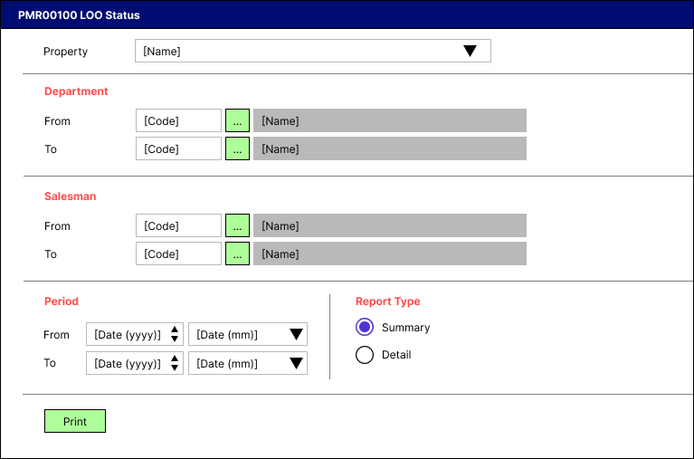

### BUTTON DEFINITION

|  |  |
| --- | --- |
| **Button Name** | **Action** |
| Print | Run PRINT REPORT PROCESS |

### DISPLAY PROCESS

#### FIELD DEFINITION

|  |  |  |  |
| --- | --- | --- | --- |
| **Name** | **Field** | **Type** | **Validation** |
| Property |  | Combo box  Set VAR_PROPERTY_LIST with  EXEC RSP_GS_GET_PROPERTY_LIST  VAR_COMPANY_ID  , VAR_USER_ID  Set property id = CPROPERTY_ID  Set property name = CPROPERTY_NAME  Set default selected property id = top 1 property id from VAR_PROPERTY_LIST.  Show name from the specific property id | * Mandatory * - |
| Department [From] |  | Lookup | * Mandatory * Enter lookup program GSL00700 with parameters: VAR_COMPANY_ID, VAR_USER_ID   And save the result to VAR_DEPARTMENT_FROM_RESULT   * If VAR_ DEPARTMENT_FROM_RESULT is empty, then: * Display message “Department [From] [INPUT Department Code] not found!”, [OK] * Set focus to Department From field * Else if VAR_DEPARTMENT_FROM_RESULT exists, then set department from name = CDEPT_NAME * - |
| Department [To] |  | Lookup | * Mandatory * Enter lookup program GSL00700 with parameters: VAR_COMPANY_ID, VAR_USER_ID   And save the result to VAR_DEPARTMENT_TO_RESULT   * If VAR_ DEPARTMENT_TO_RESULT is empty, then: * Display message “Department [To] [INPUT Department Code] not found!”, [OK] * Set focus to Department To field * Else if VAR_DEPARTMENT_FROM_RESULT exists, then set department to name = CDEPT_NAME * - |
| Salesman [From] |  | Lookup | * Mandatory * Enter lookup program LML00500 with parameters: VAR_COMPANY_ID, selected property id, VAR_USER_ID   And save the result to VAR_SALESMAN_FROM_RESULT   * If VAR_SALESMAN_FROM_RESULT is empty, then: * Display message “Salesman [From] [INPUT Salesman Code] not found!”, [OK] * Set focus to Salesman From field * Else if VAR_SALESMAN_FROM_RESULT exists, then set salesman from name = CSALESMAN_NAME * - |
| Salesman [To] |  | Lookup | * Mandatory * Enter lookup program LML00500 with parameters: VAR_COMPANY_ID, selected property id, VAR_USER_ID   And save the result to VAR_SALESMAN_TO_RESULT   * If VAR_ SALESMAN_TO_RESULT is empty, then: * Display message “Salesman [To] [INPUT Salesman Code] not found!”, [OK] * Set focus to Salesman To field * Else if VAR_SALESMAN_TO_RESULT exists, then set salesman to name = CSALESMAN_NAME * - |
| Period [From][Year] |  | Spinner  Spinner value:   * Minimum = VAR_YEAR_RANGE.IMIN_YEAR * Maximum = VAR_YEAR_RANGE.IMAX_YEAR   Set default spinner value:  SELECT YEAR(dbo.RFN_GET_DB_TODAY (VAR_COMPANY_ID)) | * Mandatory * - |
| Period [To][Year] |  | Spinner  Spinner value:   * Minimum = VAR_YEAR_RANGE.IMIN_YEAR * Maximum = VAR_YEAR_RANGE.IMAX_YEAR   Set default spinner value:  SELECT YEAR(dbo.RFN_GET_DB_TODAY (VAR_COMPANY_ID)) | * Mandatory * - |
| Period [From][Month] |  | Combo box  Set VAR_PERIOD_FROM_MONTH_LIST with  EXEC RSP_GS_GET_PERIOD_DT_LIST  VAR_COMPANY_ID  , (Period [From][Year])  Set month number = CPERIOD_NO  Set month name = January, February, … , December  Set default combo box value month name based on  SELECT MONTH(dbo.RFN_GET_DB_TODAY (VAR_COMPANY_ID)) | * Mandatory * - |
| Period [To][Month] |  | Combo box  Set VAR_PERIOD_TO_MONTH_LIST with  EXEC RSP_GS_GET_PERIOD_DT_LIST  VAR_COMPANY_ID  , (Period [To][Year])  Set month number = CPERIOD_NO  Set month name = January, February, … , December  Set default combo box value month name based on  SELECT MONTH(dbo.RFN_GET_DB_TODAY (VAR_COMPANY_ID)) | * Mandatory * - |
| Report Type |  | Radio button  Radio Value   * S = Summary * D = Detail   Set default value to summary | * Mandatory * - |

### PRINT REPORT PROCESS

#### REPORT LAYOUT

PAPER SIZE: A4 LANDSCAPE

SUMMARY

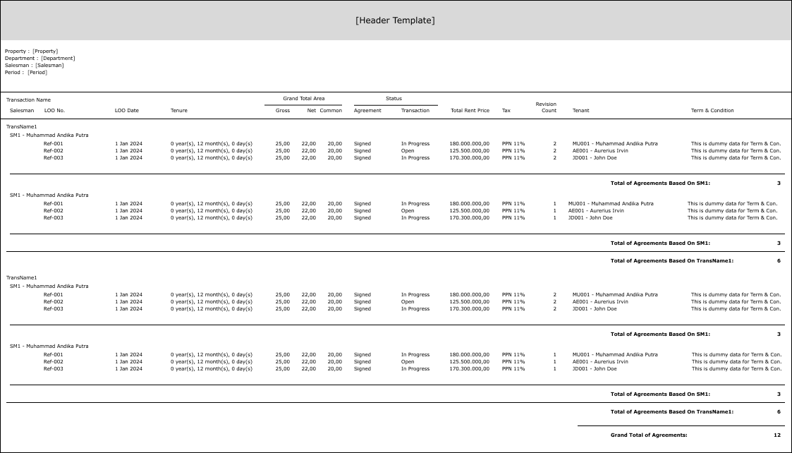

DETAIL

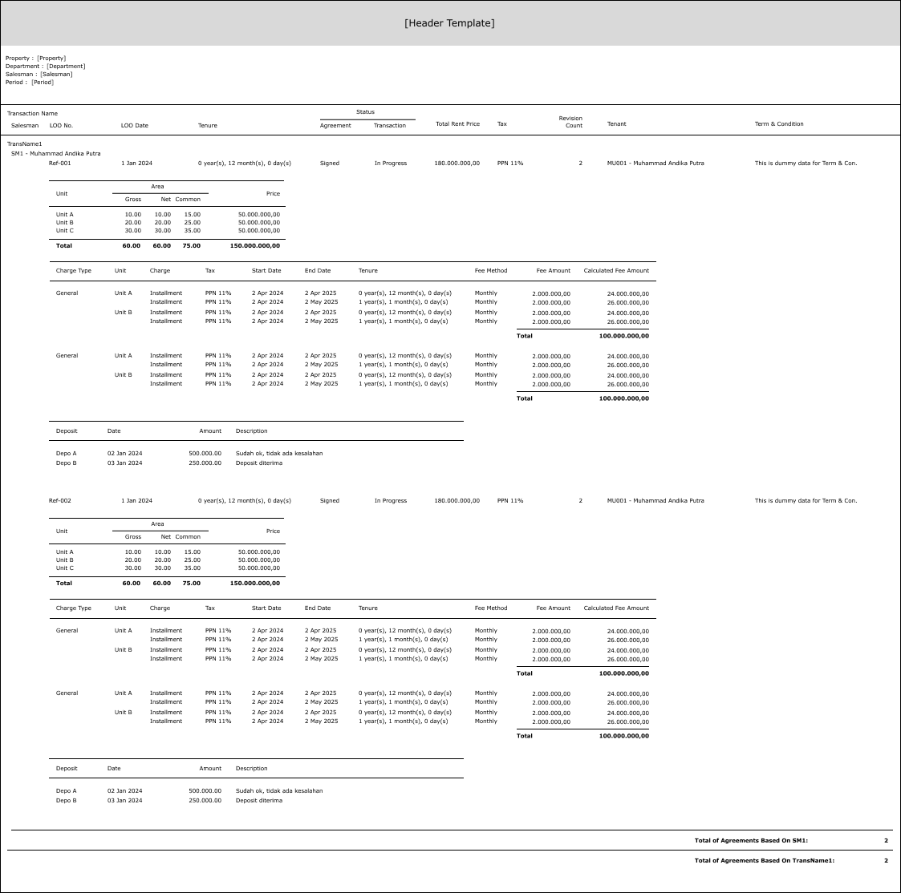

#### REPORT DEFINITION

SUMMARY

|  |  |  |  |
| --- | --- | --- | --- |
| **Report** | **Name** | **Field** | **Validation** |
| **HEADER** | Property | Selected Property ID – Property Name |  |
| Department | Selected Department ID – Department Name (From & To) | IF Department [From] <> Department [To], then “Name[From] (ID [From]) – Name[To] (ID [To])”  ELSE, “Name[From] (ID [From])”  Ex. 1 Selected from : yyy – Department Y  Selected to : zzz – Department Z  Hence, show “Department Y (yyy) – Department Z (zzz)”  Ex. 2  Selected from : yyy – Department Y  Selected to : yyy – Department Y  Hence, show “Department Y (yyy)” |
| Salesman | Selected Salesman ID – Salesman Name (From & To) | IF Salesman [From] <> Salesman [To], then “Name[From] (ID [From]) – Name[To] (ID [To])”  ELSE, “Name[From] (ID [From])”  Ex. 1 Selected from : yyy – Salesman Y  Selected to : zzz – Salesman Z  Hence, show “Salesman Y (yyy) – Salesman Z (zzz)”  Ex. 2  Selected from : yyy – Salesman Y  Selected to : yyy – Salesman Y  Hence, show “Salesman Y (yyy)” |
| Period | Selected Period [From] – Period [To] | If Period [From][Year] and Period [From][Month] <> Period [To][Year] and Period [To][Month], then “MMMM yyyy – MMMM yyyy”  Ex. Period From = “200109” and Period To = “200110”, then show “September 2001 – October 2001”  Else, show only Period [From][Year] and Period [From][Month]  Ex. “September 2001” |
| **REPORT GROUP** | Transaction | CTRANS_CODE |  |
| Salesman | CSALESMAN_ID |  |
| GROUP BY TRANSACTION | Transaction Name | CTRANS_NAME |  |
| GROUP BY SALESMAN | Salesman | CSALESMAN_ID - CSALESMAN_NAME |  |
| DETAIL | LOO No. | CREF_NO |  |
| LOO Date | CREF_DATE |  |
| Tenure | CTENURE |  |
| Grand Total Area (Gross) | NTOTAL_GROSS_AREA_SIZE |  |
| Grand Total Area (Net) | NTOTAL_NET_AREA_SIZE |  |
| Grand Total Area (Common) | NTOTAL_COMMON_AREA_SIZE |  |
| Agreement Status | CAGREEMENT_STATUS_NAME |  |
| Transaction Status | CTRANS_STATUS_NAME |  |
| Revision Count | NREVISION_COUNT |  |
| Total Rent Price | NTOTAL_PRICE |  |
| Tax | CTAX |  |
| Tenant | CTENANT_ID - CTENANT_NAME |  |
| Term & Condition | CTC_MESSAGE |  |
| **Summarize** | Total of Agreements based on Salesman |  | Count of CREF_NO, group by CSALESMAN_ID |
| Total of Agreements based on Transaction Name |  | Count of CREF_NO, group by CTRANS_CODE |
|  | Grand Total of Agreements |  | Count of CREF_NO |

DETAIL

|  |  |  |  |
| --- | --- | --- | --- |
| **Report** | **Name** | **Field** | **Validation** |
| **HEADER** | Property | Selected Property ID – Property Name |  |
| Department | Selected Department ID – Department Name (From & To) | IF Department [From] <> Department [To], then “Name[From] (ID [From]) – Name[To] (ID [To])”  ELSE, “Name[From] (ID [From])”  Ex. 1 Selected from : yyy – Department Y  Selected to : zzz – Department Z  Hence, show “Department Y (yyy) – Department Z (zzz)”  Ex. 2  Selected from : yyy – Department Y  Selected to : yyy – Department Y  Hence, show “Department Y (yyy)” |
| Salesman | Selected Salesman ID – Salesman Name (From & To) | IF Salesman [From] <> Salesman [To], then “Name[From] (ID [From]) – Name[To] (ID [To])”  ELSE, “Name[From] (ID [From])”  Ex. 1 Selected from : yyy – Salesman Y  Selected to : zzz – Salesman Z  Hence, show “Salesman Y (yyy) – Salesman Z (zzz)”  Ex. 2  Selected from : yyy – Salesman Y  Selected to : yyy – Salesman Y  Hence, show “Salesman Y (yyy)” |
| Period | Selected Period [From] – Period [To] | If Period [From][Year] and Period [From][Month] <> Period [To][Year] and Period [To][Month], then “MMMM yyyy – MMMM yyyy”  Ex. Period From = “200109” and Period To = “200110”, then show “September 2001 – October 2001”  Else, show only Period [From][Year] and Period [From][Month]  Ex. “September 2001” |
| **REPORT GROUP** | Transaction | CTRANS_CODE |  |
| Salesman | CSALESMAN_ID |  |
| LOO No. | CREF_NO |  |
| GROUP BY TRANSACTION | Transaction Name | CTRANS_NAME |  |
| GROUP BY SALESMAN | Salesman | CSALESMAN_ID - CSALESMAN_NAME |  |
| GROUP BY LOO NO. | LOO No. | CREF_NO |  |
| LOO Date | CREF_DATE |  |
| Tenure | Tenure |  |
| Agreement Status | CAGREEMENT_STATUS_NAME |  |
| Transaction Status | CTRANS_STATUS_NAME |  |
| Revision Count | NREVISION_COUNT |  |
| Total Rent Price | NTOTAL_PRICE |  |
| Tax | CTAX |  |
| Tenant | CTENANT_ID - CTENANT_NAME |  |
| Term & Condition | CTC_MESSAGE |  |
| SECTION 1 DETAIL | Unit | CUNIT_DETAIL_ID - CUNIT_DETAIL_NAME | If (CUNIT_DETAIL_ID is null and count of CUNIT_DETAIL_ID = 0), then suppress the whole SECTION 1 |
| Gross Area | NUNIT_DETAIL_GROSS_AREA_SIZE |  |
| Net Area | NUNIT_DETAIL_NET_AREA_SIZ |  |
| Common Area | NUNIT_DETAIL_COMMON_AREA_SIZE |  |
| Rent Price | NUNIT_DETAIL_PRICE | If 0, then suppress |
| SECTION 1 FOOTER | Total of Gross Area | NUNIT_TOTAL_GROSS_AREA_SIZE |  |
| Total of Net Area | NUNIT_TOTAL_NET_AREA_SIZE |  |
| Total of Common Area | NUNIT_TOTAL_COMMON_AREA_SIZE |  |
| Total of Price | NUNIT_TOTAL_PRICE | If 0, then suppress |
| SECTION 2 [1] HEADER | Charge Type | CCHARGE_DETAIL_TYPE_NAME | If (CCHARGE_DETAIL_TYPE_NAME is null and count of CCHARGE_DETAIL_TYPE_NAME based on CREF_NO = 0), then suppress the whole SECTION 2 |
| SECTION 2 [2] HEADER | Unit | CCHARGE_DETAIL_UNIT_NAME |  |
| SECTION 2 [2] DETAIL | Charge | CCHARGE_DETAIL_CHARGE_NAME |  |
| Tax | CCHARGE_DETAIL_TAX_NAME |  |
| Start Date | CCHARGE_DETAIL_START_DATE |  |
| End Date | CCHARGE_DETAIL_END_DATE |  |
| Tenure | CCHARGE_DETAIL_TENURE |  |
| Fee Method | CCHARGE_DETAIL_FEE_METHOD |  |
| Fee Amount | NCHARGE_DETAIL_FEE_AMOUNT |  |
| SECTION 2 [2] FOOTER | Calculated Fee Amount | NCHARGE_DETAIL_CALCULATED_FEE_AMOUNT |  |
| SECTION 2 [1] FOOTER | Total of Fee Amount | NCHARGE_DETAIL_SUBTOTAL_CALCULATED_FEE_AMOUNT |  |
| SECTION 3 DETAIL | Deposit | CDEPOSIT_DETAIL_ID | If (CDEPOSIT_DETAIL_ID is null and count of CDEPOSIT_DETAIL_ID based on CREF_NO = 0), then suppress the whole SECTION 3 |
| Date | CDEPOSIT_DETAIL_DATE |  |
| Amount | NDEPOSIT_DETAIL_AMOUNT |  |
| Description | CDEPOSIT_DETAIL_DESCRIPTION |  |
| **Summarize** | Total of Agreements by Salesman |  | Count of CREF_NO, group by CSALESMAN_ID |
| Total of Agreements by Transaction Name |  | Count of CREF_NO, group by CTRANS_CODE |
| Grand Total of Agreements |  | Count of CREF_NO |

#### VALIDATION

|  |  |  |
| --- | --- | --- |
| **Field** | **Condition** | **Validation Message** |
| Property | Empty | Please select Property! |
| Department [From] | Department [From [Code]] is empty | Please select Department (From)! |
| Department [To] | Department [To [Code]] is empty | Please select Department (To)! |
| Department [To [Code]] is higher than Department [From [Code]] | Department (To) is higher than Department (From) |
| Salesman [From] | Salesman [From [Code]] is empty | Please select Salesman (From)! |
| Salesman [To] | Salesman [To [Code]] is empty | Please select Salesman (To)! |
| Salesman [To [Code]] is higher than Salesman [From [Code]] | Salesman (To) is higher than Salesman (From) |
| Period [To] | Period [To] is higher than Period [From] | Period (To) is higher than Period (From)! |

#### ACTION

|  |
| --- |
|  |
| * Execute this stored procedure:   RSP_PMR00100_GET_REPORT  VAR_COMPANY_ID  , selected Property ID  , selected Department [From] ID  , selected Department [To] ID  , selected Salesman [From] ID  , selected Salesman [To] ID  , selected Period [From]  , selected Period [To]  , VAR_LANGUAGE_ID  There are **two** types of report;  If type = S, then open report for **Summary**  Else if type = D, then open report for **Detail**  Ex.  EXEC RSP_PMR00100_GET_REPORT  'RCD'  , 'ASHMD'  , 'ACC'  , 'FIN'  , 'C098'  , 'TEST02'  , '202404'  , '202406'  , 'EN' |

# CR LIST

|  |  |  |
| --- | --- | --- |
| **CR** | **Description** | **Notes** |
|  |  |  |

#### TEMPLATE

#### VALIDATION

|  |  |  |
| --- | --- | --- |
| **Field** | **Condition** | **Validation Message** |
|  |  |  |
|  |  |  |

#### ACTION

|  |
| --- |
|  |
|  |